**INDEX**

|  |  |  |
| --- | --- | --- |
| **Sr No.** | **Content** | **Page No.** |
| **1.** | **Project description** | 4-6 |
|  | 1.1 Project Profile | 4 |
|  | 1.2 Project introduction | 5 |
|  | 1.3 Project Definition | 5-6 |
| **2.** | **Project Planning** | 7 |
|  | 2.1 Scope | 7 |
|  | 2.2 Goal | 7 |
|  | 2.3 Constraints | 7 |
| **3.** | **Environment Description** | 8-11 |
|  | 3.1 Hardware Specification | 8-9 |
|  | 3.2 Technology used/ Software Requirements | 10-11 |
| **4.** | **System Description** | 11-16 |
|  | 4.1 Feasibility Study | 11 |
|  | 4.2 Requirement Analysis/Data Gathering | 12 |
|  | 4.3 System development process model | 13-16 |
| **5.** | **Advantages of system** | 17-18 |
|  | 5.1 Advantages of system | 17 |
|  | 5.2 Security issues add precaution | 18 |
| **6.** | **System designing** | 19-32 |
|  | 6.1 Data Dictionary | 19-22 |
|  | 6.2 Database design/Table design | 23-26 |
|  | 6.3 Data Flow Diagram | 27-31 |
|  | 6.4 E-R Diagram | 31-32 |
| **7.** | **System modules** | 33-47 |
|  | 7.1 Screen Layout | 33-42 |
|  | 7.2 Report layouts | 43-44 |
|  | 7.3 Backup and Restore (optional) | 45-47 |
| 8. | System testing | 45-47 |
| 9. | Future enhancement | 48 |
| 10. | Bibliography | 49 |

# 1.Project Description

## 1.1Project Profile

|  |  |
| --- | --- |
| Project Name: | Icecream Store |
| Operating System: | Windows 10,11 |
| Server-Side Scripting language: | PHP Version 7.4.26 |
| Front End: | HTML , Bootstrap 5 , CSS , Javascript |
| Back End: | MY SQL |

1.2 Introduction

**The Ice Cream Shop Management System is designed to efficiently manage records of orders, sales, and customer preferences in an ice cream shop. It helps the admin retrieve order history and customer details using their registered contact number.**

**The system provides various features, including:**

* **Adding and managing different categories of ice cream (e.g., gelato, sorbet, soft-serve, sundaes).**
* **Recording and managing details of ice cream flavors, and pricing.**
* **Tracking order status and maintaining records of purchases.**
* **Generating invoices for customers.**
* **Generating sales reports based on date and time.**
* **Helping customers access their order history by logging in with their registered email and password.**
* **Supporting multiple payment options, including UPI, net banking, credit/debit cards, and cash.**

1.3 Project Definition

**The Ice Cream Shop Management System is a structured and automated solution that ensures smooth operations in an ice cream shop by efficiently handling sales, inventory, and customer preferences. It improves customer experience by providing real-time order tracking and seamless payment options.**

**The system:**

* **Organizes ice cream flavors and categories based on type, ingredients, or customer preferences.**
* **Reduces order processing time by maintaining a quick and easy checkout process.**
* **Allows scalability to accommodate new flavors, ., or promotions.**
* **Facilitates cashless payments through UPI, credit/debit cards, and other digital methods.**

**Main Modules of the System**

**• Module 1: Admin Panel  
The admin panel is used by the shop owner or manager to configure and control the system. It includes:**

* **Viewing and managing ice cream inventory.**
* **Adding/removing flavors, and offers.**
* **Managing customer accounts and order details.**
* **Generating reports on sales, popular flavors, and revenue.**
* **Auto-calculating pricing based on size, quantity, and additional ..**

**• Module 2: Customer Panel  
Customers can use the system to:**

* **View their past orders using their registered email or phone number.**
* **Place orders and choose icecream options.**
* **Make payments using UPI,COD.**

**This Ice Cream Shop Management System ensures a hassle-free experience for both the business and its customers while optimizing operations and enhancing customer satisfaction.**

# 2.Project Planning

## 2.1 Scope

**The scope of this project is the Ice Cream Shop Management System, which is developed as a website to handle ice cream orders, inventory, and customer interactions online.**

**The project is designed to:**

* **Computerize all details regarding ice cream categories, flavors, and ..**
* **Organize ice cream inventory efficiently based on type, availability, and demand.**
* **Maintain an up-to-date record of customer orders for historical and analytical purposes.**
* **Provide real-time updates on available flavors, promotions, and seasonal offerings.**

## 2.2 Goal

**The main goal of developing the Ice Cream Shop Management System is to automate the ordering process, manage inventory, and provide an easy-to-use system for both customers and administrators. The system ensures smooth order processing, automatic price calculations, and secure transactions online.**

**The system aims to be:**

* **User-friendly – Simple and easy to navigate for both customers and admin.**
* **Fast & Efficient – Quick order processing and seamless checkout.**
* **Cost-effective – Reduces manual work and improves operational efficiency.**

## 2.3 System constaints

* **The system is currently designed for online use only.**
* **A high-speed internet connection is required for smooth functionality.**

# 3.Environment description

## 3.1 Hardware Requirements

* **Operating System: Windows 10,11**
* **Browser Support: Google chrome , Microsoft Edge**
* **Minimum Ram : 4 GB**
* **Hard Disk:100 Mb**
* **Processor:Intel(R) Core(TM) i3-1005G1 CPU @ 1.20GHz 1.19 GHz**

## 3.2 Technology Used/Software Requirements

* **PHP (Hypertext Pre-processor)**
* **MySQL 5.7.36**
* **PhpMyAdmin 5.1.1,**
* **Apache 2.4.51**
* **WampServer 3.2.6 - 64bit**

## PHP( Hypertext Pre-processor)

Overview of PHP

**PHP is a server-side scripting language designed primarily for web development but also used as a general-purpose programming language Originally created by** [**Rasmus Lerdorf i**](http://en.wikipedia.org/wiki/Rasmus_Lerdorf)**n 1994.PHP scripts are executed on the server.**

What is PHP?

* **PHP is an acronym for "PHP: Hypertext Pre-processor"**
* **PHP is a widely-used, open-source scripting language**
* **PHP costs nothing, it is free to download and use**

What Can PHP Do?

* **PHP can generate dynamic page content.**
* **PHP can create, open, read, write, delete, and close files on the server.**
* **PHP can collect form data.**
* **PHP can send and receive cookies.**
* **PHP can add, delete, modify data in your database.**
* **PHP can restrict users to access some pages on your website.**
* **PHP can encrypt data.**

Why PHP?

**A good benefit of using PHP is that it can interact with many different database languages including MySQL. We work with MySQL at Student internal marks assessment system since this is also a free language so it makes sense to use PHP. Both PHP and MySQL are compatible with an Apache server which is also free to license. PHP can also run on Windows, Linux and Unix servers.**

**PHP also has very good online documentation with a good** [**framework o**](http://www.bluelinemedia.co.uk/blog/shouldyouuseframeworkswhencoding)**f functions in place. This makes the language relatively easy to learn and very well supported online. There are countless forums and tutorials on various PHP methods and problems so it is usually very easy to find help if you need it.**

**Due to PHP being so accessible and cheap to setup there are a lot of people who know how to use the language which makes finding new patients proficient in this language less challenging.**

## Wamp Server

**WAMP is an acronym that stands for Windows, Apache, MySQL, and PHP. It’s a software stack which means installing WAMP installs** [**Apache,**](https://www.hostinger.com/tutorials/what-is-apache) [**MySQL,**](https://www.hostinger.com/tutorials/what-is-mysql) **and PHP on your operating system (Windows in the case of WAMP). Even though you can install them separately, they are usually bundled up, and for a good reason too.**

**What’s good to know is that WAMP derives from** [**LAMP**](https://www.hostinger.com/tutorials/how-to-install-lamp-ubuntu-16-04) **(the L stands for Linux). The only difference between these two is that WAMP is used for Windows, while LAMP – for Linux based operating systems.**

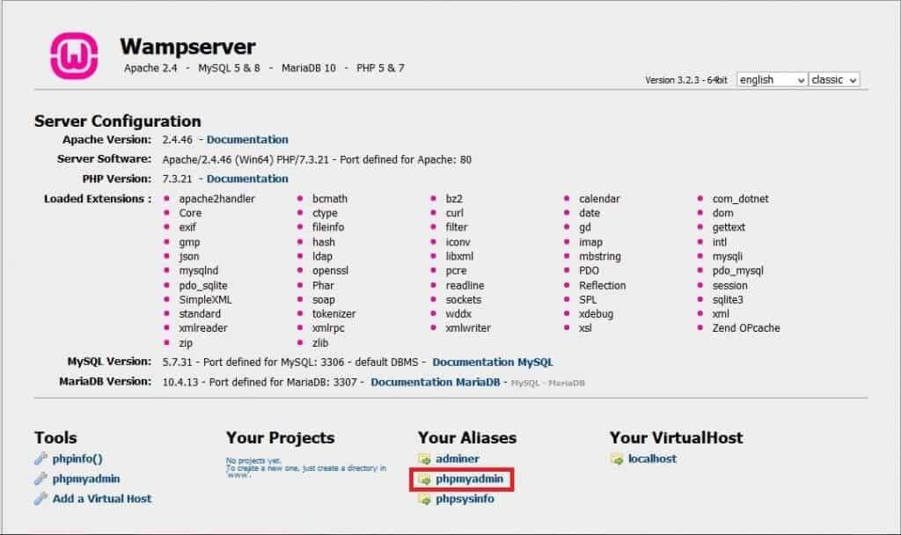

**Let’s quickly go over what each letter represents:**

1. **“W” stands for Windows, there’s also LAMP (for Linux) and MAMP (for Mac).**
2. **“A” stands for Apache. Apache is the server software that is responsible for serving web pages. When you request a page to be seen by you, Apache grants your request over HTTP and shows you the site.**
3. **“M” stands for MySQL. MySQL’s job is to be the database management system for your server. It stores all the relevant information like your site’s content, user profiles, etc.**
4. **“P” stands for PHP. It’s the programming language that was used to write WordPress. It acts like glue for this whole software stack. PHP is running in conjunction with Apache and communicating with MySQL.**

## MySQL

Overview of MySQL

**-MySQL is an open-source relational database management system (RDBMS). Its name is a combination of "My", the name of co-founder Michael Widenius's daughter My, and "SQL", the acronym for Structured Query Language.**

**-MySQL is written in C and Ct. Its SQL parser is written in yace, but it uses a home- brewed lexical analyzer.**

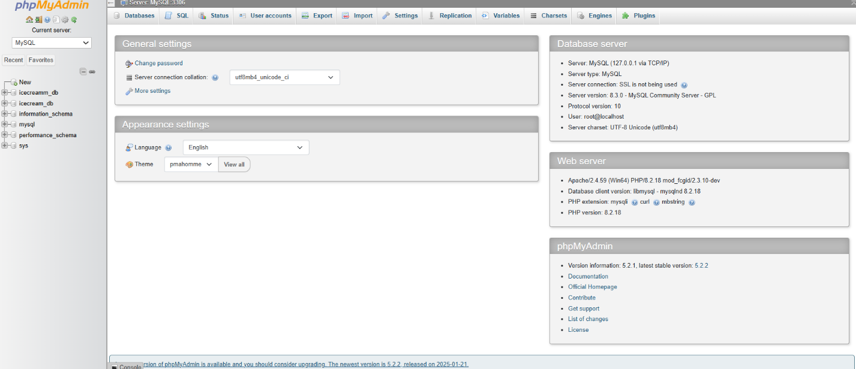

**-MySQL is a database system that runs on a server .**

**-MySQL is ideal for both small and large registrations.**

**-MySQL is the most popular database system used with PHP.**

**-The MySQL Database Server is very fast, reliable, scalable, and easy to use.**

# 4.System description

## 4.1 Feasibility analysis

**Feasibility analysis begins once the goals are defined. It starts by generating broad possible solutions, which are possible to give an indication of what the new system should look like. This is where creativity and imagination are used. Analysts must think up new ways of doing things- generate new ideas. There is no need to go into the detailed system operation yet. The solution should provide enough system will fit into the organization. It is important not to exert considerable effort at this stage only to find out that the project is not worthwhile or that there is a need significantly change the original goal.**

**Feasibility of a new system means ensuring that the new system, which we are going to implement, is efficient and affordable. There are various types of feasibility to be determined. They are, Economically Feasibility:**

**The system being developed is economic with respect to managed hospital point of view. It is cost effective in the sense that has eliminated the paper work completely.. The result obtained contains minimum errors and are highly accurate as the data is required.**

**Technical feasibility:**

**The technical requirement for the system is economic and it does not use any other additional Hardware and software.**

**Behavioural/Operational Feasibility:**

**The system working is quite easy to use and learn due to its simple but attractive interface. User requires no special training for operating the system.**

4.2 Data Gathering:

**Gathering is a process of collecting information about the system requirement and desired preferences by using research, interviews, meeting, questionnaires, sampling, and other techniques. The Data Gathering involves:-**

1. **Interviews**
2. **Questionnaires**
3. **Record review**

**Interviews:**

**Interviews are a data fact finding technique where the system analyst who acts as an interviewer collects fact from individuals (interviewees).the respondents (interviewees) are generally current users of the existing system or potential user of the proposed system. The respondents may be admin who provide data for the proposed system or those who will be affected it.**

**Advantages:**

* **This method of fact finding would be helpful for gathering information from individual who Cannot communicate effectively in writing.**
* **Allowing participants to express themselves in own words. Investigating problems.**

**Questionnaires:**

**Questionnaires are special purpose documents that allow the analyst to collect Information and opinions from respondents. When it is impossible of time, distance, or cost analyst, to interview all the desired people. Involved in a system, then the analyst may consider the use of the questionnaire. When information is gathered by requesting users to fill in a pre-defined form then these forms are called questionnaires.**

**Advantages:**

* **Data collected through questionnaires are relatively cheap, particularly when there is a scattered group of users and operators.**
* **Responses from questionnaires can be tabulated and analysed quickly. Investigating your “market share” .**

**Record review:**

**A good analyst always gets facts from documents. An existing system can be better understood by examining existing documents, forms, and files. This record review can take place at the beginning of the system study or later in the study for comparing actual operations with what the records indicate.**

## **Requirements Analysis**

**Organizational Requirements**

**To manage the Ice Cream Shop Management System, the organization needs individuals with different roles to carry out various activities:**

* **Admin: Manages all system functions, including inventory management, employee records, sales reports, invoicing, and data backup.**
* **Customer: Creates an account to place orders, view past purchases, and make payments. Customers have minimal system access, limited to ordering and payments.**
* **Staff: Handles customer orders, manages stock, updates menu availability, and processes payments.**
* **Supplier: Provides inventory such as ingredients, packaging, and .. Suppliers can update stock availability and manage invoices.**

**Functional Requirements**

## **Data Entry: Admins can enter new flavors, ., promotional offers, and pricing into the system.**

## **Order Management: Customers should be able to place orders, customize their ice creams, and choose payment options.**

## **Billing & Invoicing: The system should generate invoices for each order and store transaction history.**

## **Sales Reports: The system should generate reports on best-selling flavors, seasonal demand, and revenue trends.**

## **Non-Functional Requirement**

**Usability:**

* **Proper message on successful task.**
* **Proper handling of errors.**
* **Facility to view the available data in the system database.**

**Security:**

* **Web Application should support multiple users and their respective privileges.**
* **Page validations to prevent illegal data.**

**Performance:**

* **Web Application should perform well in all general browsers.**

**Scalability:**

* **It should be scalable to the future Requirements.**
* **It should be able to handle tremendous traffic and future changes.**

**4.3 System Development Process Model:**

**Water fall model:**

* **Is a kind of system development strategy that works strictly according to the steps defined in the Software Development Life Cycle.**
* **Like SDLC, in Water-Fall model, begin with planning the system which involves finding out the problem to which the solution is to be found, and define a strategy that we are going to use for developing the system.**
* **The next stage is the analysis stage in which we analyse the existing system and find various system related facts.**
* **In analysis stage we aim at obtaining answers to the question queried by the client.**
* **After The analysis stage we move on to the designing stage where we design the database as well as the screen which will provide interface to the end users.**
* **The last stage involves the testing of the system, which involves testing the system from all aspects.**

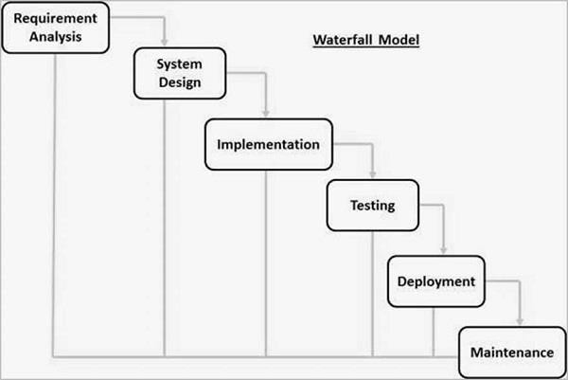

**Stages of the Waterfall Model Explained:**

**Requirement Analysis**

**All possible requirements of the system to be developed are captured in this phase. Requirements are a set of functions and constraints that the end user (who will be using the system) expects from the system. The requirements are gathered from the end user at the start of the software development phase. These requirements are analysed for their validity, and the possibility of incorporating the requirements in the system to be developed is also studied. Finally, a requirement specification document is created which serves the purpose of guideline for the next phase of the model. System Design**

**Before starting the actual coding phase, it is highly important to understand the requirements of the end user and also have an idea of how should the end product looks like. The requirement specifications from the first phase are studied in this phase and a system design is prepared. System design helps in specifying hardware and system requirements and also helps in defining the overall system architecture. The system design specifications serve as an input for the next phase of the model.**

**Implementation and Unit Testing**

**On receiving system design documents, the work is divided in modules/units and actual coding is started. The system is first developed in small programs called units, which are integrated in the next phase. Each**

**unit is developed and tested for its functionality; this is referred to as unit testing. Unit testing mainly verifies if the modules/units meet their specifications.**

**Integration and System Testing**

**As specified above, the system is first divided into units which are developed and tested for their functions. These units are integrated into a complete system during integration phase and tested to check if all modules/units coordinate with each other, and the system behaves as per the specifications. After successfully testing the software, it is delivered to the seeker Tomer.**

**Operations & Maintenance**

**This phase of the waterfall model is virtually a never-ending phase. Generally, problems with the system developed (which are not found during the development life cycle) come up after its practical use starts, so the issues related to the system are solved after deployment of the system. Not all the problems come into picture directly but they arise from time to time and need to be solved; hence this process is referred to as maintenance. Advantages of the Waterfall Model:**

* **There is clear compartmentalization of work and control in the waterfall model. Since there is compartmentalization, it is easier to set schedule for the tasks to be completed within a specified time period.**
* **The other advantage of this model is that only after the work for a particular phase is over, does the other phase start, due to which there is no overlapping of phases or the product does not have to go through different iterative steps.**
* **This model is the easiest to implement in the eyes of most of the mangers, due to its linear model. Since the processes of this model are carried out in linear manner, the cost of resources is reduced to a large extent, which in turn helps in reducing the cost of the project considerably.**
* **Lastly, the documentation and testing happens at the end of each phase, which helps in maintaining the quality of the project.**

# 5.Advantages and System

5.1 Advantage of System:

* **Less paper work and time saving.**
* **Easy to use.**
* **Digital vehicle records.**
* **Improved efficiency by avoiding human errors.**
* **Maintain security**
* **Giving accurate information**
* **User friendly**
* **Enables to view large volume of data in short time**

5.2 Security Issues and Precaution:

**The security features are considered while developing the system, so as to avoid the errors and omission that may lead to serious problems .The system may have to face the unwanted events called threats.**

**Computer systems is secure against a particular threat if counter measures have been taken to reduce an acceptability low level amount of loss that the treat may be expected to cause over given period of time .**

**A computer should be protected from the following three problems:**

* **Loss of availability**
* **Loss of integrity**
* **Loss of confidentiality**

**These problems may adversely affect the ability of computer system to carry out its intended task .Threat to a computer system is any event that a adversely affect the one or more assets or resources , which make up the system.**

**An event can be any of the following:**

* **Interruption of communication**
* **Destruction of hardware**
* **Modification of software**
* **Removal of programs**
* **Disclosure of information**

**There are many methods for handling a threat:**

* **Avoid it by altering the design**
* **Threat retention**
* **Treat reduction i.e., the frequency of occurrence of a threat is reduced**

**There are many possible threats to the security and integrity of any system where more than one user is associated with the system. Software integrity has become increasingly important. The attribute measures a system’s ability to withstand attacks, both accidental and intentional on its security .Attacks can be made on all the three components of software: programs data and documents.**

**In this project the data security, data validation checking methods are applied using a password authentication. All the data, which is entered by the staff and administrator, will be validated. Users should enter their username and password for requesting access.**

**The system is also secured in such a way that even the slightest deviation in inputting the data will invoke error messages and provide necessary guidelines regarding the input.**

# **6.System Design**

**What is Data Dictionary?**

**In database management systems, a file that defines the basic organization of a database. A data dictionary contains a list of all files in the database, the number of records in each file, and the names and types of each field. Most database management systems keep the data dictionary hidden from users to prevent them from accidentally destroying its contents.**

**Data dictionaries do not contain any actual data from the database, only book keeping information for managing it. Without a data dictionary, however, a database management system cannot access data from the database.**

**A data dictionary is a collection of descriptions of the data objects or items in a data model for the benefit of programmers and others who need to refer to them. A first step in analysing a system of objects with which users interact is to identify each object and its relationship to other objects. This process is called data modelling and results in a picture of object relationships. After each data object or item is given a descriptive name, its relationship is described (or it becomes part of some structure that implicitly describes relationship), the type of data (such as text or image or binary value) is described, possible predefined values are listed, and a brief textual description is provided.**

**This collection can be organized for reference into a book called a data dictionary.**

**Why is a Data Dictionary Important?**

**Analysts use data dictionary for the following reasons:**

* **To manage the details in the large system.**
* **To communicate a common meaning for all system elements.**
* **To document the features of the system.**
* **To locate error and omission in the system.**

## 6.1 Data Dictionary

|  |  |  |  |
| --- | --- | --- | --- |
| SR. NO | FIELD NAME | WHERE TO USE | HOW  TO  USE |
| 1 | id | cart | I/P |
| 2 | user_id | cart | O/P |
| 3 | product_id | cart | O/P |
| 4 | Price | cart | Both |

## 

|  |  |  |  |
| --- | --- | --- | --- |
| 5 | qty | cart | I/P |
| 6 | added_on | cart | O/P |
| 7 | **Name** | **categories** | O/P |
| 8 | id | **categories** | O/P |
| 9 | category | **categories** | O/P |
| 10 | id | **message** | O/P |
| 11 | user_id | **message** | O/P |
| 12 | name | **message** | O/P |
| 13 | email | **message** | O/P |
| 14 | subject | **message** | O/P |
| 15 | message | **message** | O/P |
| 16 | id | **order** | O/P |
| 17 | user_id | **order** | O/P |
| 18 | seller_id | **order** | O/P |
| 19 | name | **order** | O/P |
| 20 | number | **order** | O/P |
| 21 | email | **order** | O/P |
| 22 | address | **order** | O/P |
| 23 | address_type | **order** | Both |
| 24 | method | **order** | Both |
| 25 | product_id | **order** | I/P |
| 26 | price | **order** | O/P |
| 27 | qty | **order** | I/P |
| 28 | dates | **order** | O/P |
| 29 | id | **products** | O/P |
| 30 | seller_id | **products** | O/P |
| 31 | name | **products** | O/P |
| 32 | price | **products** | O/P |
| 33 | images | **products** | O/P |
| 34 | stock | **products** | O/P |
| 35 | product_id | **products** | O/P |
| 36 | Status | **products** | O/P |
| 37 | Description | **products** | O/P |
| 38 | Name | Rate table | O/P |
| 39 | id | **sellers** | O/P |
| 40 | name | **sellers** | O/P |
| 41 | email | **sellers** | O/P |
| 42 | password | **sellers** | O/P |
| 43 | image | **sellers** | O/P |
| 44 | id | **users** | O/P |
| 45 | name | **users** | O/P |
| 46 | email | **users** | O/P |
| 47 | password | **users** | O/P |
| 48 | image | **users** | O/P |
| 49 | id | **Wishlist** | O/P |
| 50 | user_id | **Wishlist** | O/P |
| 51 | product_id | **Wishlist** | O/P |

## 6.2Table Design

**TABLE: CART**

|  |  |  |
| --- | --- | --- |
| **Name** | **Data Type** | **Description** |
| id | Varchar (20) | Unique identifier for the cart |
| user_id | int | ID of the user |
| product_id | int | ID of the product |
| Price | int | Price of the product |
| qty | int | Quantity of product |
| added_on | timestamp |  |

**TABLE:CATEGORIES**

|  |  |  |
| --- | --- | --- |
| **Name** | **Data type** | **Description** |
| id | int | Unique identifier for category |
| category | varchar(20) | categories |

**TABLE: MESSAGE**

|  |  |  |
| --- | --- | --- |
| **Name** | **Data Type** | **Description** |
| id | Varchar(20) | Unique identifier for the message |
| user_id | Varchar(20) | ID of the user sending the message |
| name | Varchar (100) | Name of the sender |
| email | Varchar (100) | Email of the sender |
| subject | Varchar (100) | Subject of the message |
| message | Varchar (1000) | Content of the message |

**TABLE: ORDER**

|  |  |  |  |
| --- | --- | --- | --- |
| **Name** | **Data Type** | **Description** | **Name** |
| id | Varchar(20) | Unique order ID | id |
| user_id | Varchar(20) | ID of the user | user_id |
| seller_id | Varchar (20) | ID of the seller | seller_id |
| name | Varchar (50) | Name of the buyer | name |
| number | Varchar (10) | Contact number of the buyer | number |
| email | Varchar (50) | Email of the buyer | email |
| address | Varchar (20) | Shipping address | address |
| address_type | Varchar (10) | Address type (home/office) | address_type |
| method | Varchar (50) | Payment method | method |
| product_id | Varchar (20) | Product ID | product_id |
| price | Varchar (10) | Price of the product | price |
| qty | Varchar (2) | Quantity of product | qty |
| dates | timestamp | Date of order | dates |

**TABLE: PRODUCTS**

|  |  |  |
| --- | --- | --- |
| **Name** | **Data Type** | **Description** |
| id | varchar(20) | Product ID |
| seller_id | varchar(20) | Seller ID |
| name | varchar(20) | Product name |
| price | int | Product price |
| images | varchar(100) | Image of the product |
| stock | int | Stock quantity |
| product_id | varchar(1000) | Unique product identifier |
| Status | varchar(100) | Product status |
| Description | varchar(1000) | detail of product |

**TABLE: SELLERS**

|  |  |  |
| --- | --- | --- |
| Name | Data type | Description |
| id | varchar(20) | Unique identifier for seller |
| name | varchar(50) | Seller's name |
| email | varchar(50) | Seller's email |
| password | varchar(50) | Seller's password |
| image | varchar(100) | Seller's profile image |

**TABLE: USERS**

|  |  |  |
| --- | --- | --- |
| Name | Data type | Description |
| id | varchar(20) | Unique identifier for user |
| name | varchar(50) | user's name |
| email | varchar(50) | user's email |
| password | varchar(50) | user's password |
| image | varchar(100) | user's profile image |

**TABLE: Wishlist**

|  |  |  |
| --- | --- | --- |
| **Name** | **Data Type** | **Description** |
| id | Varchar (20) | Unique identifier for the cart |
| user_id | int | ID of the user |
| product_id | int | ID of the product |

## 6.3 Data Flow Diagram

**Definition**

**Data flow is a network diagram illustrating a computerized system, manual or a combination of both, and representation in the form of a set of structured system components that are interconnected in accordance with the rules play. Advantages of DFD is possible to describe the system from the highest level and then them into a lower level (decomposition), whereas the lack of the DFD does not indicate the process is looping, decision-making process and the process of calculation.**

Data Flow Diagram

Symbols

Several rules are used in drawing DFD:

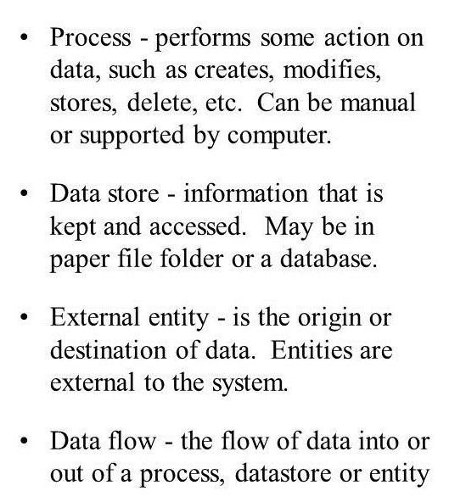

**1.Process should be named and numbered .Each should be representative of the process**

**2.The direction if flow is from top to bottom and from left to right.**

**3.When a process is exploded into lower-level details, they are numbered.**

**0 level DFD for user and admin**

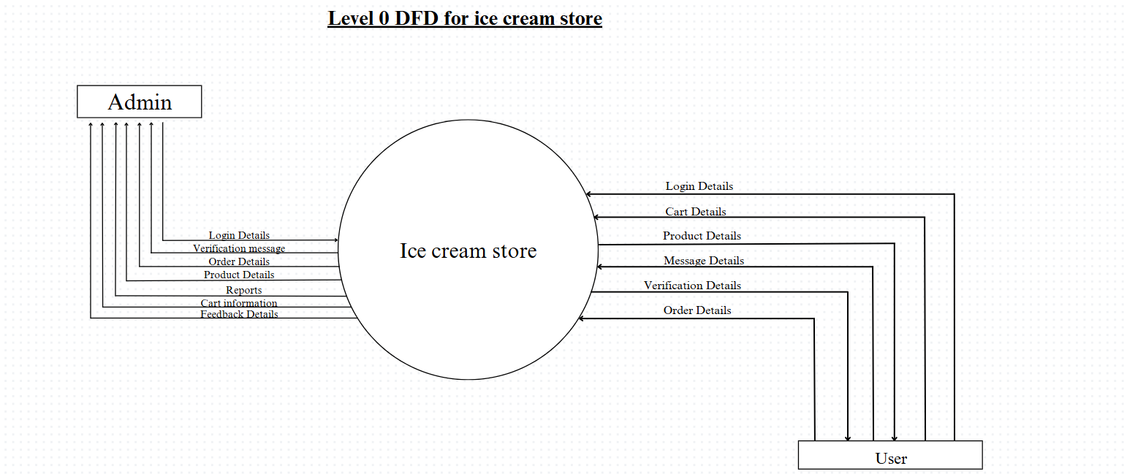

**1st level DFD for admin**

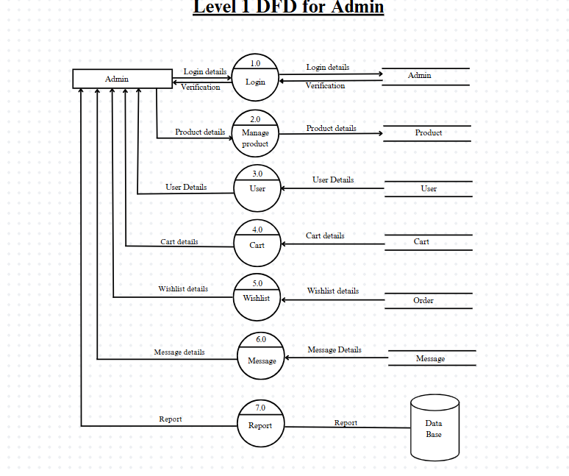

**1st level DFD for admin**

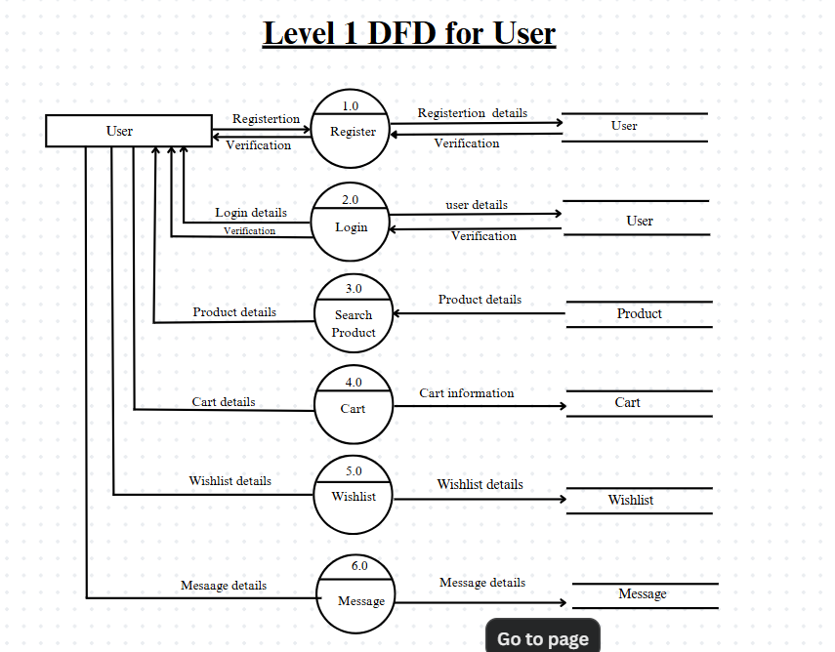

**2nd level DFD for admin**

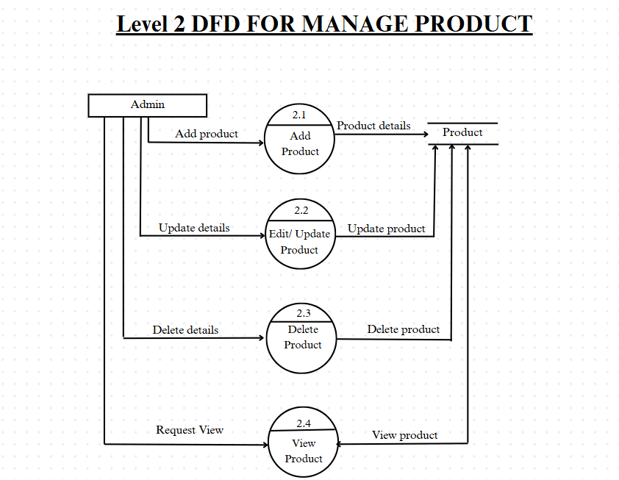

**2nd level DFD for USER**

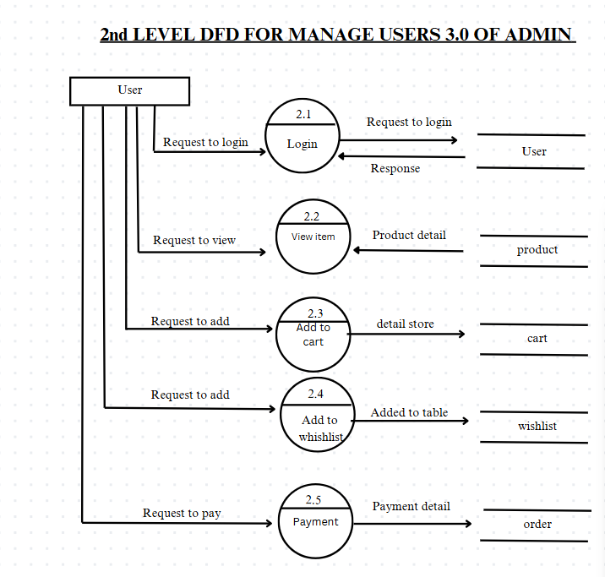

## **6.4 ER-Diagram**

**The set of symbols we have used in E-R diagrams. There is no universal standard for E-R diagram notation, and different books and E-R diagram software are different notations. Figure indicates some of the alternative notations that are widely used. An entity set may be represented as a box with the name outside, and the attributes.**

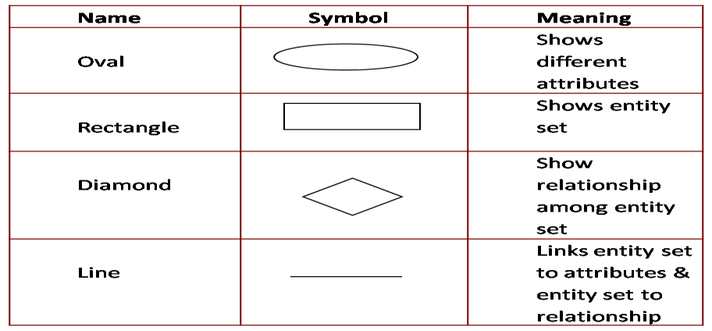

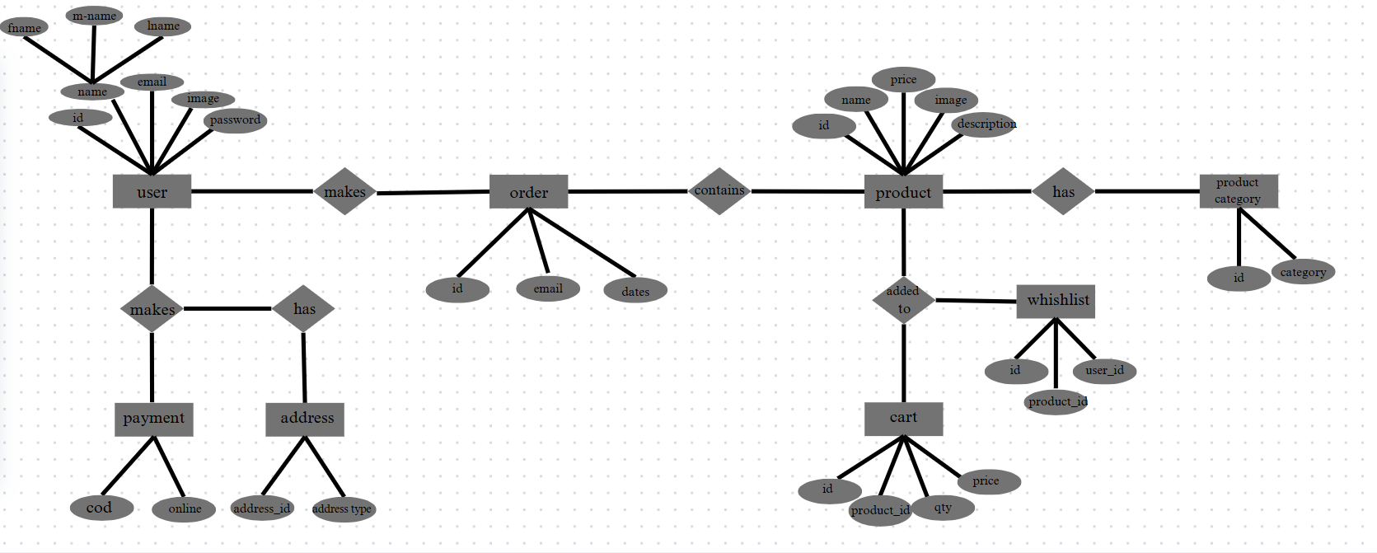

# 7.System Modules

## 7.1 Screen Layout

**User Side:**

**index page: user will see this page first**

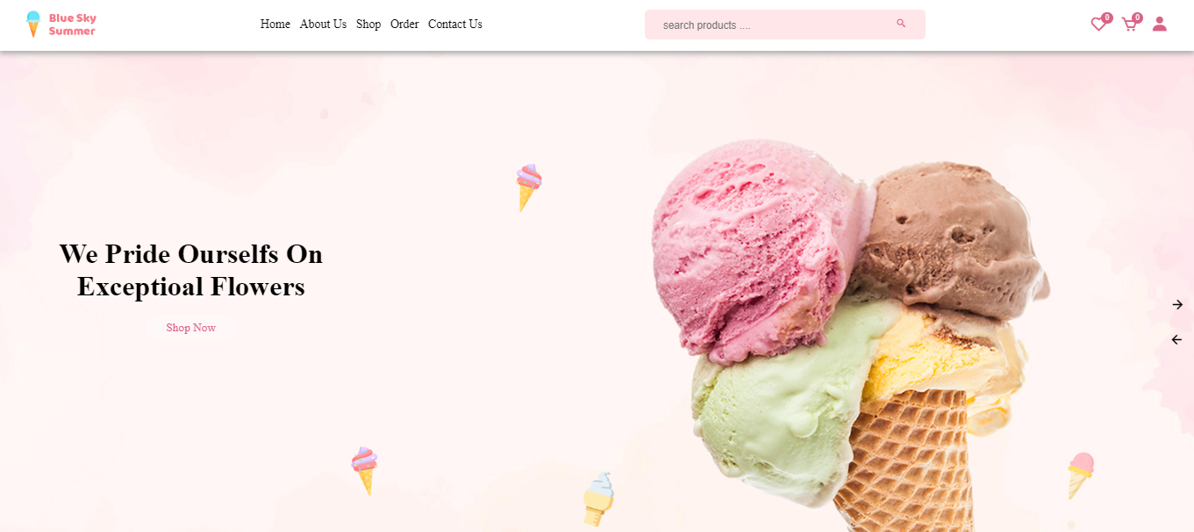

**About Page: About section, where user sees the about of the website  
  
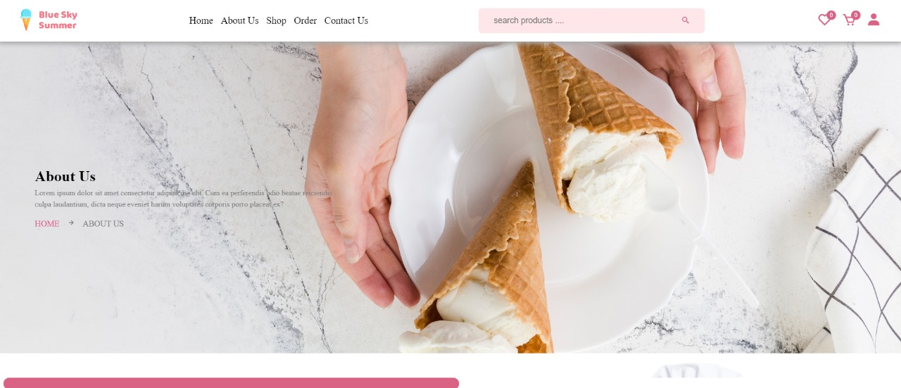**

**Registration:  Users are able to register from here.**

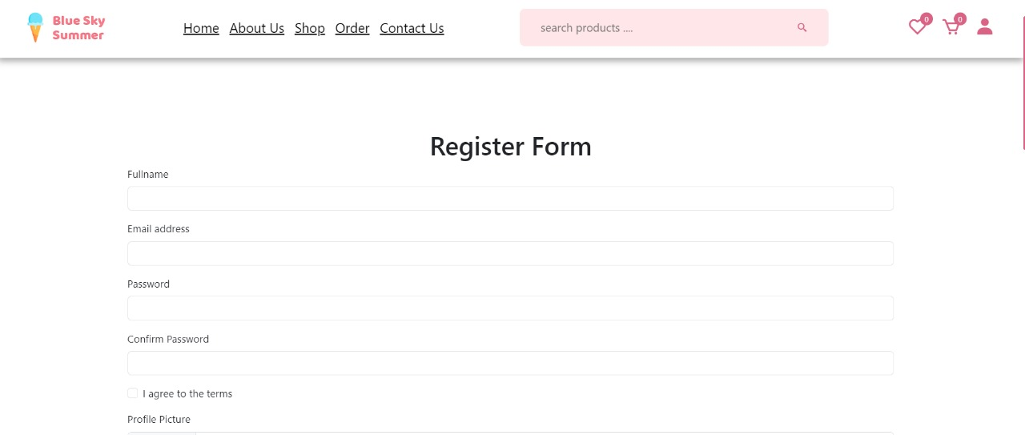

**Login Page: Admin and User both are able to log in from here.**

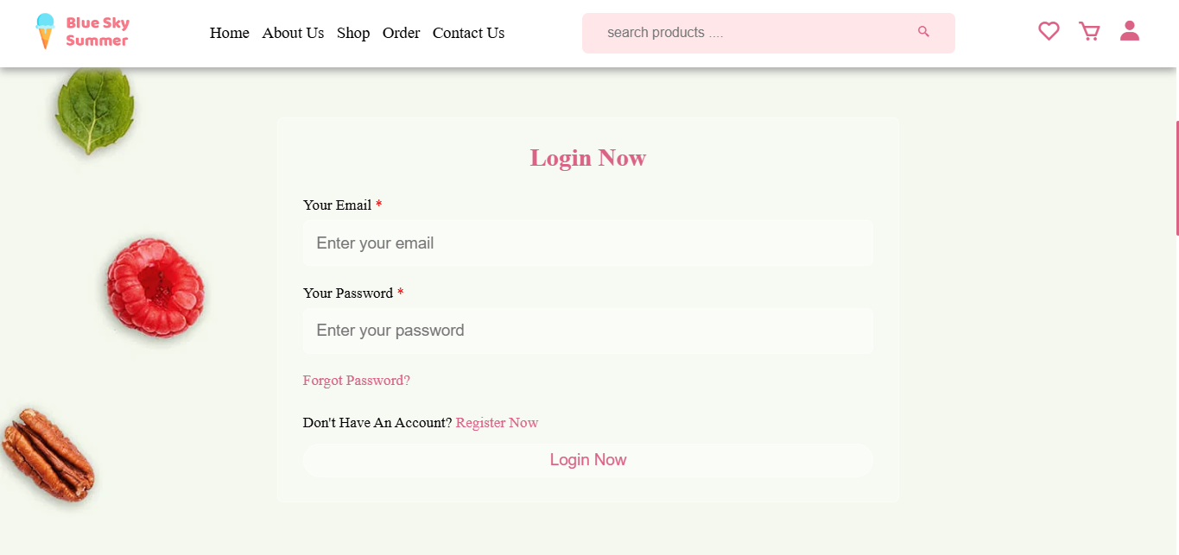

**User forget: if user forget the password**

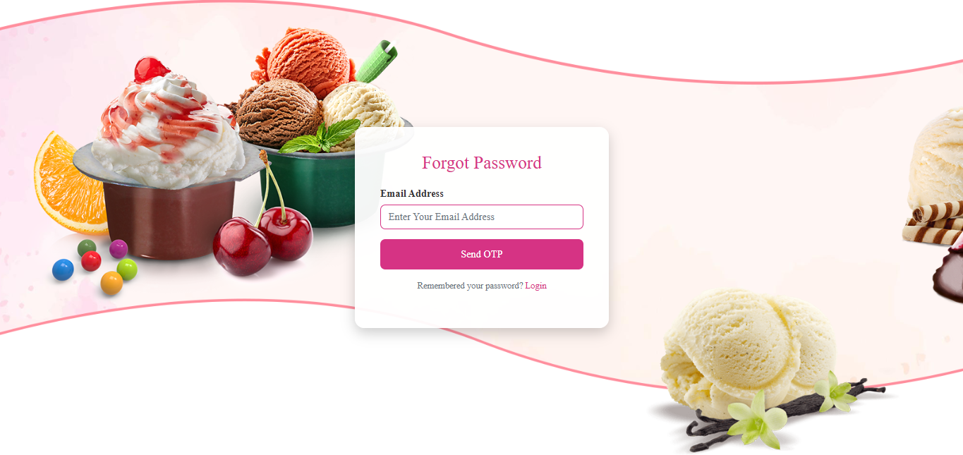

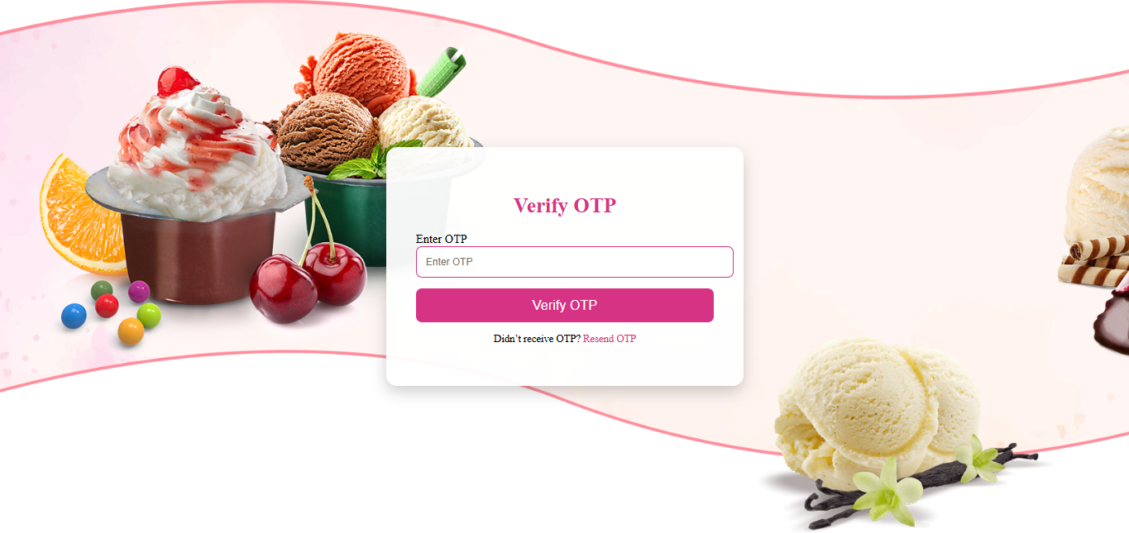

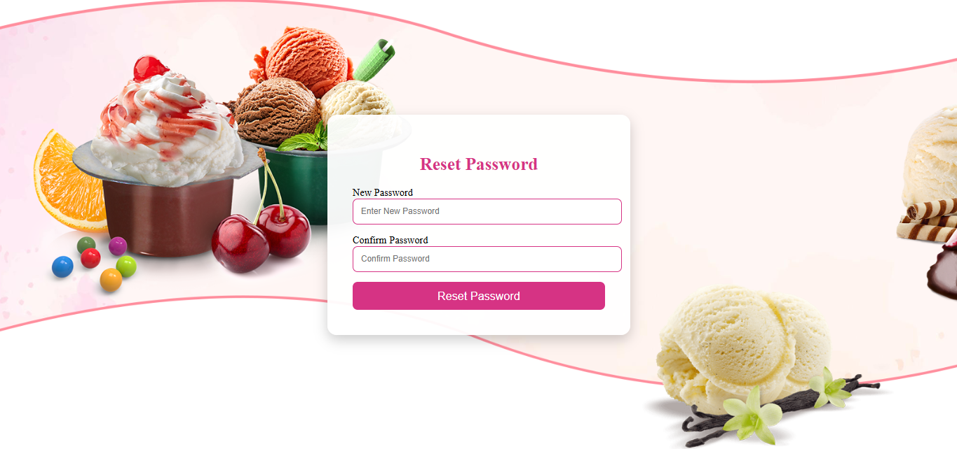

**User dashboard: After login user will re-direct to user dashboard**

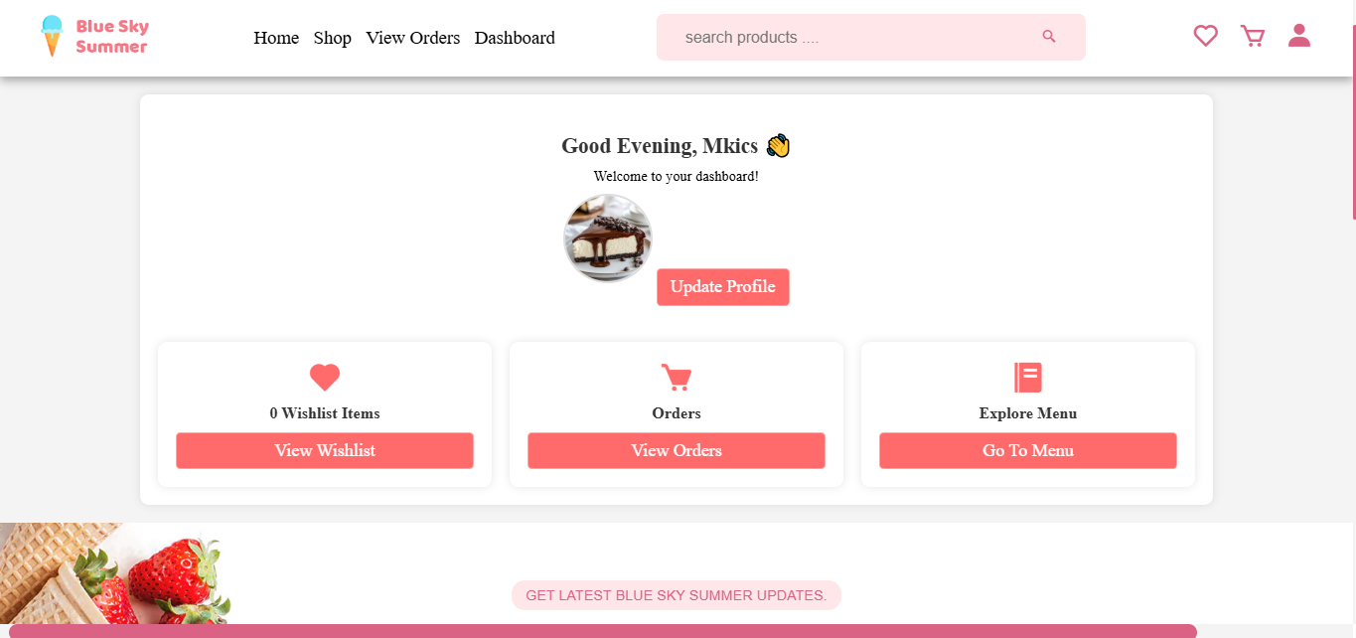

**User wishlist: After login user can see the product and put it in the wishlist**

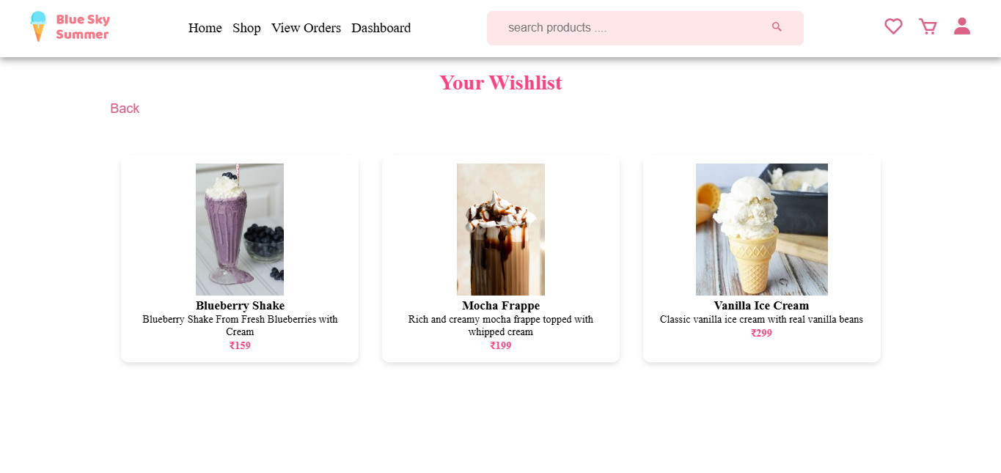

**User cart: After login user can see the product and put it in the cart from there he can buy later.**

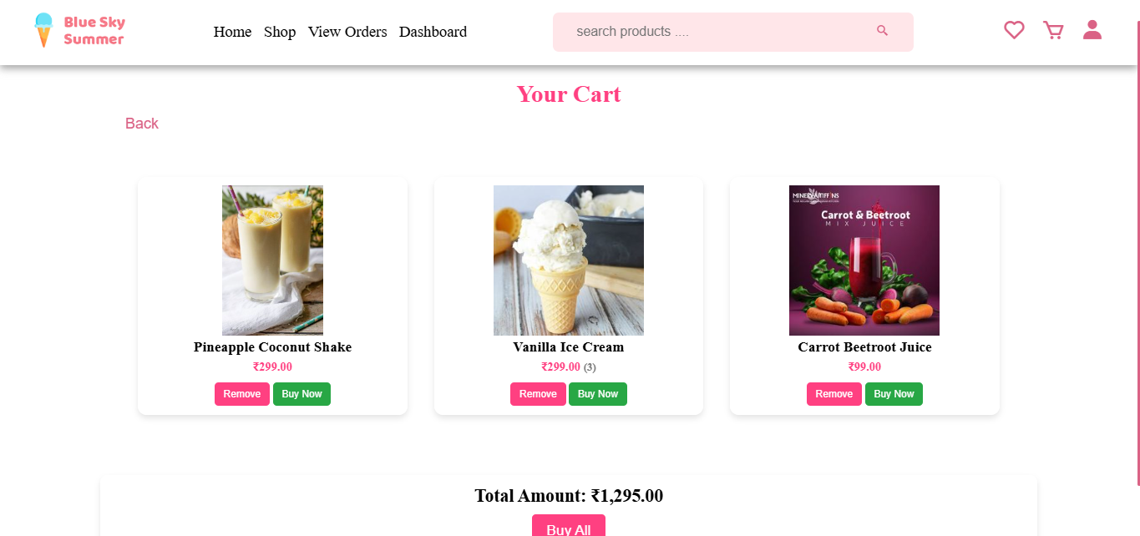**Buy Now : if user want to buy at a time then he can**

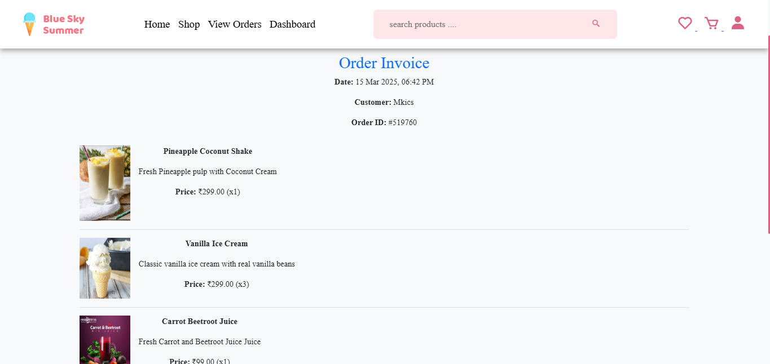

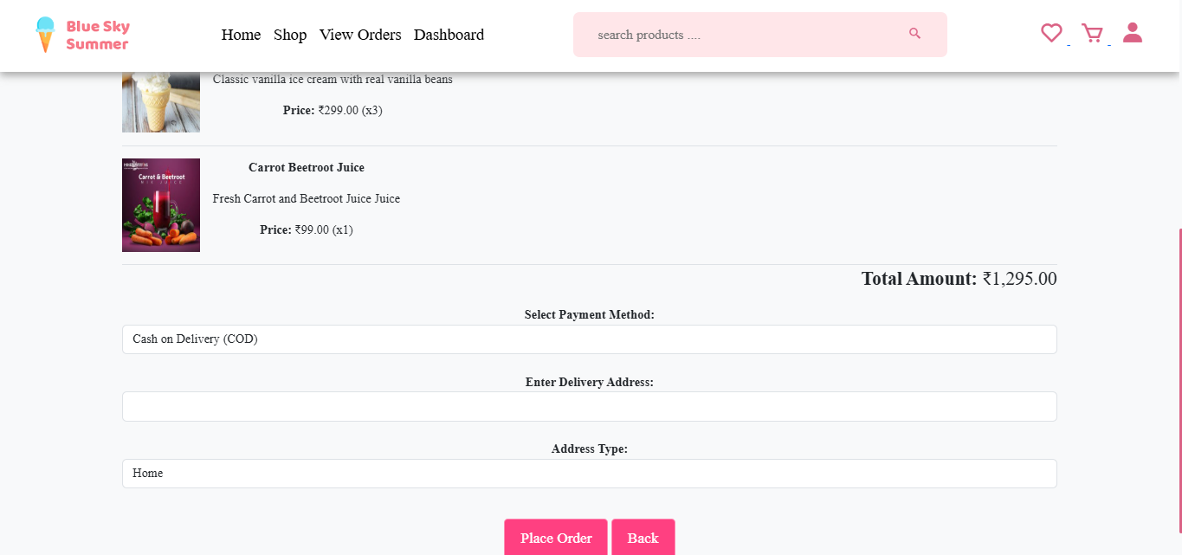

**User order page:**

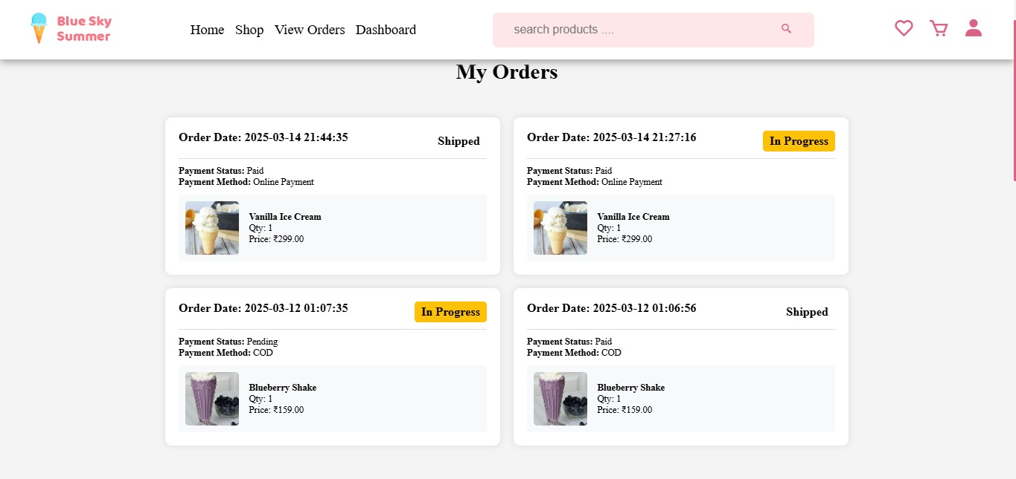

**Admin Side:   
  
Admin Dashboard:  After login admin will re-direct to admin dashboard**

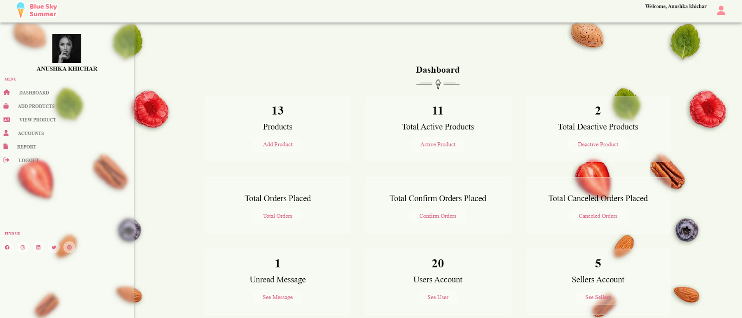

**Add Product: From Add  product page admin can add  the product and it’s details.**

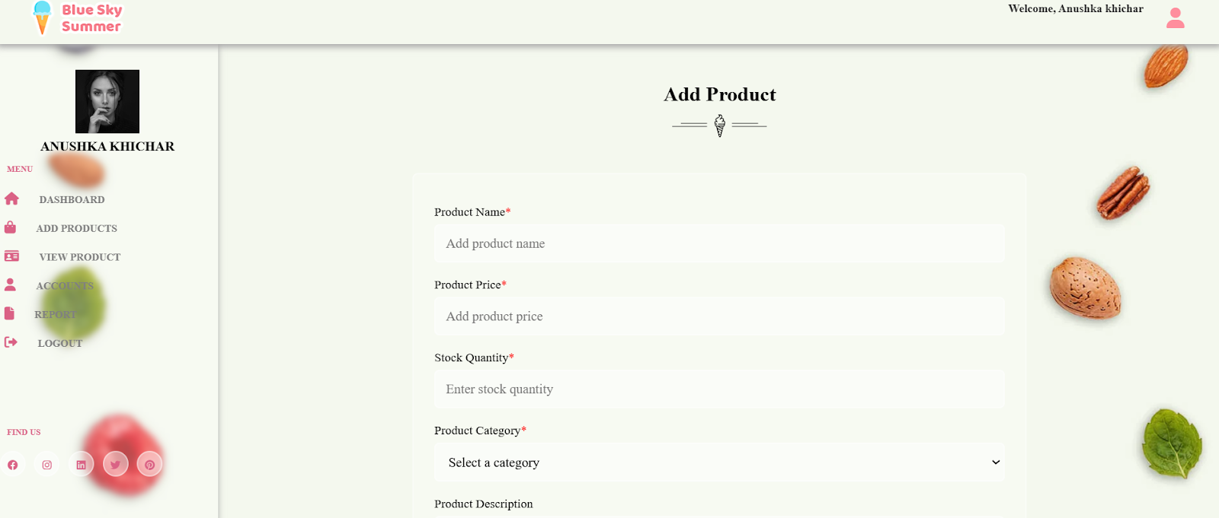

**View Product: From view product page admin can view the product and it’s details.**

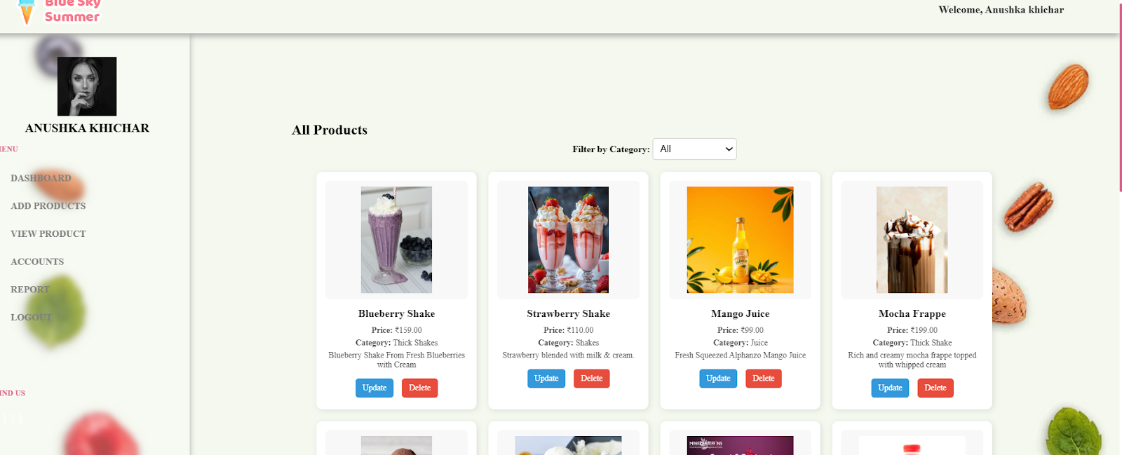

**Update Product: From view page admin can update products**

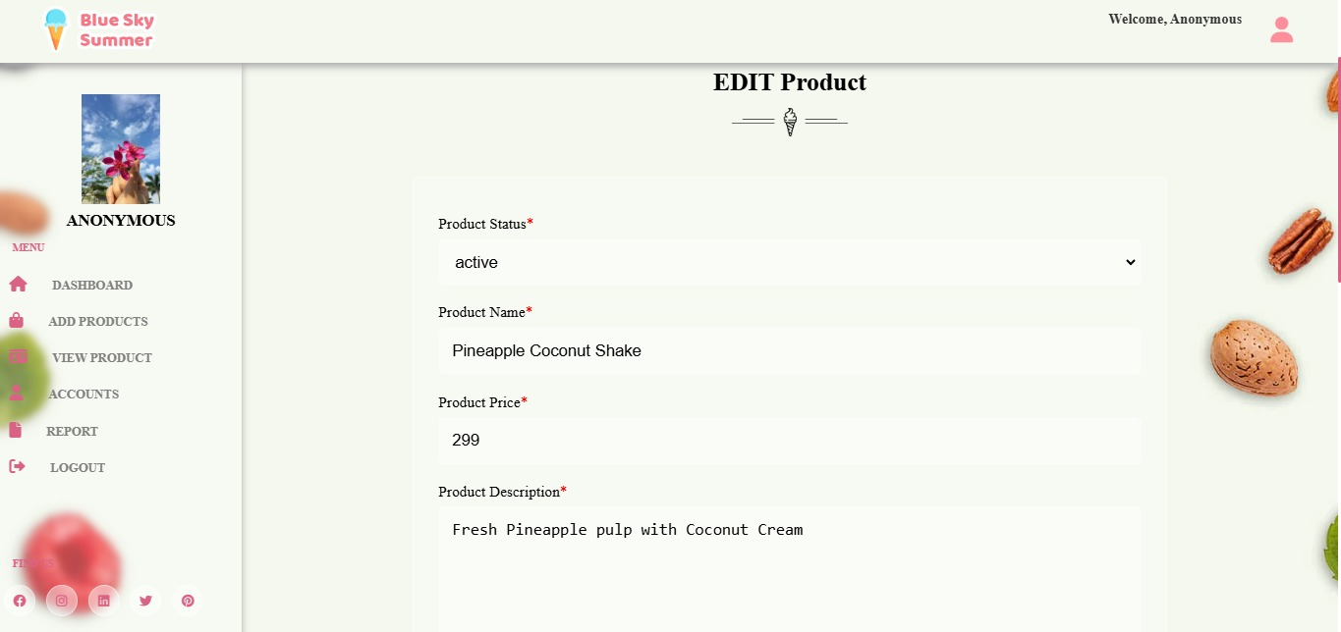

**Registered Users: From registered user admin can see the users who register themselves**

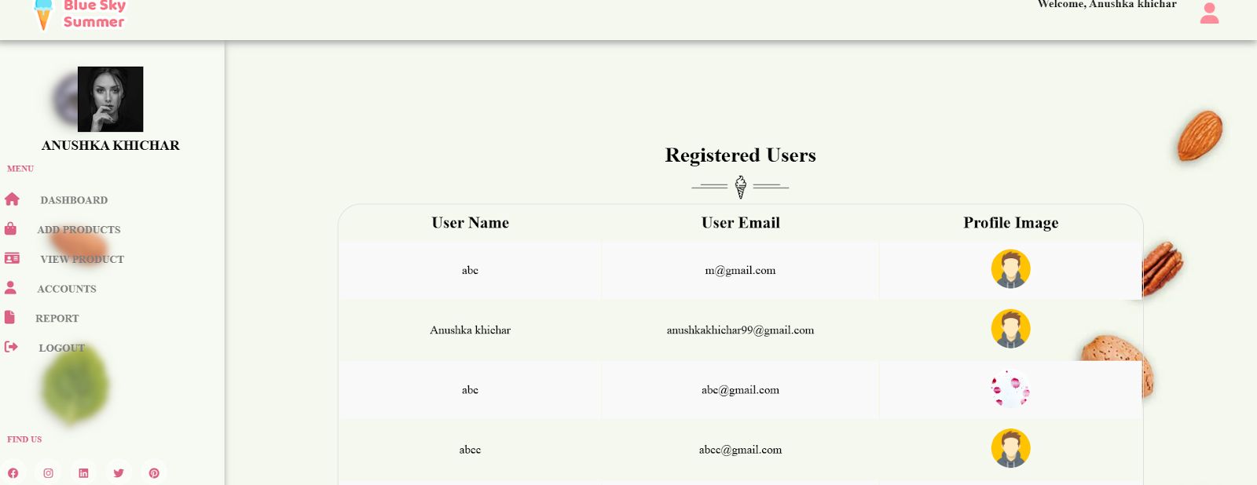

**Report page : report in which admin can see the detail**

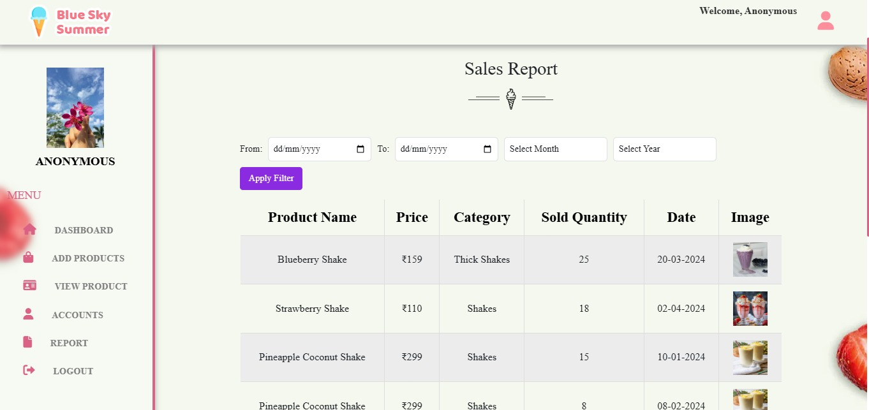

**Order page: Admin can see the orders and give the command**

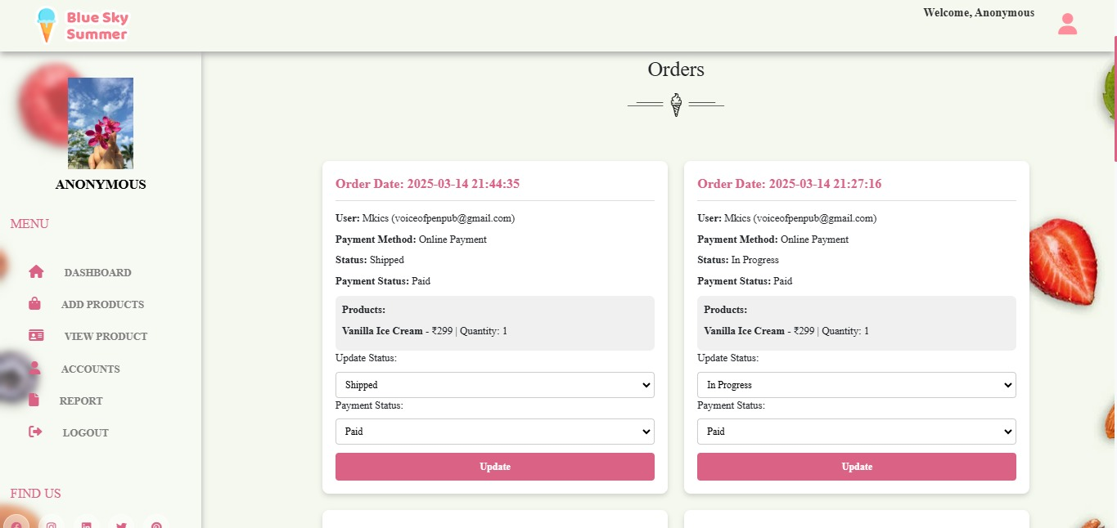

**Update Profile: Admin can update their profile from Update profile page.**

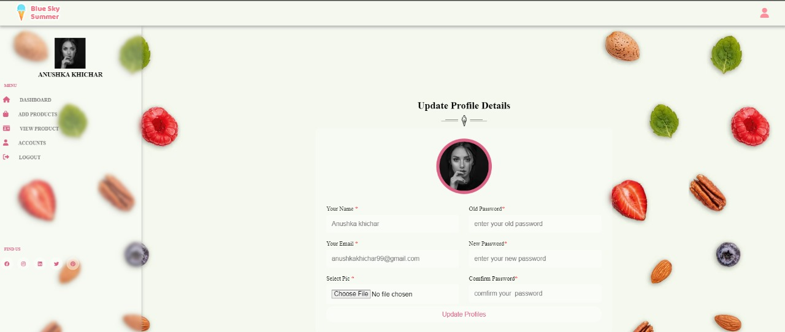

**7.3 Backup and Restore:**

**Because data is the heart of the enterprise, it's crucial for you to protect it. And to protect your organization's data, you need to implement a data backup and recovery plan. Backing up files can protect against accidental loss of user data, database corruption, hardware failures, and even natural disasters. It's your job as an administrator to make sure that backups are performed and that backup tapes are stored in a secure location.**

**Creating a Backup and Recovery Plan**

**Data backup is an insurance plan. Important files are accidentally deleted all the time. Missioncritical data can become corrupt. Natural disasters can leave your office in ruin. With a solid backup and recovery plan, you can recover from any of these. Without one, you're left with nothing to fall back on.**

**Restore- restore the database using the contents of the selected back-up file.**

1. **Taking Backup of Database:-**

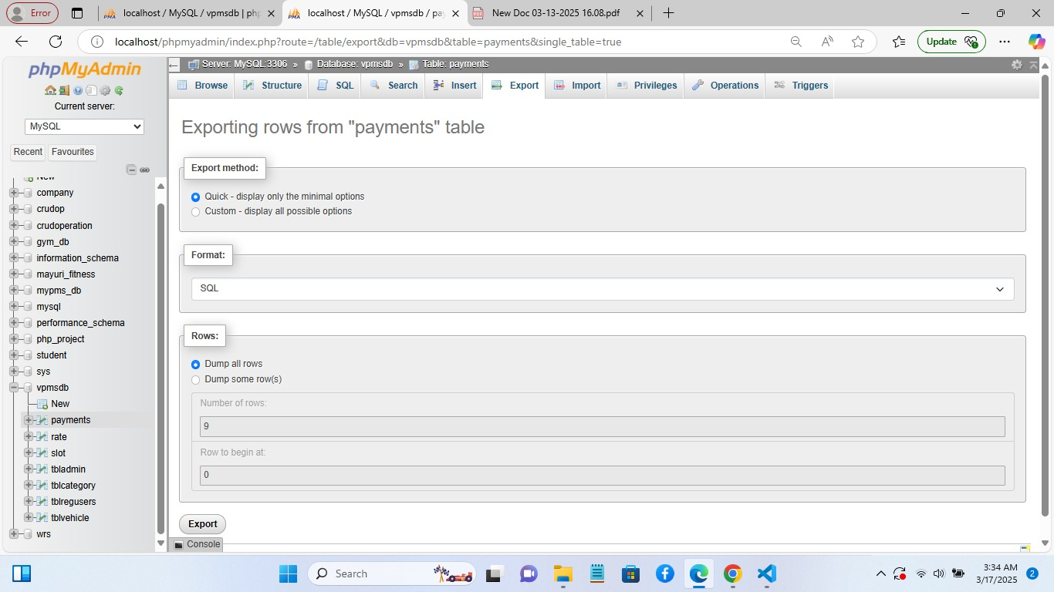

**User can get the backup from this page, user can download the database in different formats like SQL,XML,PDF etc.**

**2.Restoring Database:-**

* 1. **Log into phpMyAdmin.**
  2. **Select the destination database on the left pane.**
  3. **Click on the Import tab in the top center pane. In import tab, we can see the page like following figure.**
  4. **Under the File to import section, click Browse and locate the file with the .sql extension you wish to import.**
  5. **Check or uncheck the boxes for 'Partial import' and 'Other options'.**
  6. **From the Format dropdown menu choose 'SQL'.**
  7. **Click the Go button at the bottom to import the database.**

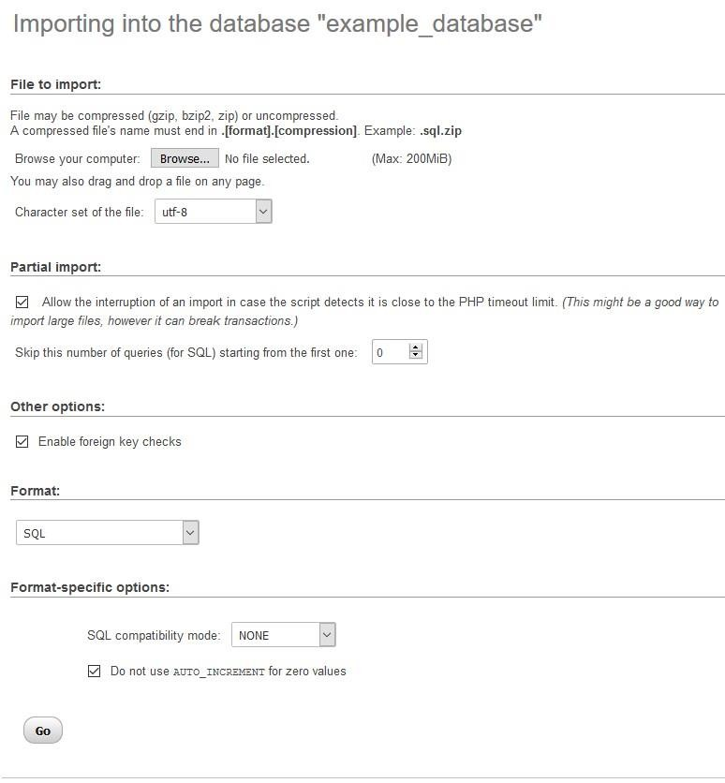

# 8.System Testing

**Once source code has been generated, software must be tested to uncover (and correct) as many errors as possible before delivery to seeker. Our goal is to design a series of test cases that have a**

**high likelihood of finding errors. To uncover the errors software techniques are used. These techniques provide systematic guidance for designing test that**

* **Exercise the internal logic of software components, and**
* **Exercise the input and output domains of the program to uncover errors in program function, behaviour and performance.**

**Steps:**

**Software is tested from two different perspectives:**

* **Internal program logic is exercised using ―White box test case design Techniques.**
* **Software requirements are exercised using ―block box test case Design techniques.**

**In both cases, the intent is to find the maximum number of errors with the minimum amount of effort and time.**

**Testing Methodologies:**

**A strategy for software testing must accommodate low-level tests that are necessary to verify that a small source code segment has been correctly implemented as well as high-level tests that validate major system functions against seeker requirements. A strategy must provide guidance for the practitioner and a set of milestones for the manager. Because the steps of the test strategy occur at a time when deadline pressure begins to rise, progress must be measurable and problems must surface as early as possible. Following testing techniques are well known and the same strategy is adopted during this project testing**

**Unit testing:**

**Unit testing focus verification effort on the smallest unit of software design- the software component or module. The unit test is white-box oriented. The unit testing implemented in every modules of Hospital Management System. By giving correct manual input to the system, the data are stored in database and retrieved. If you want required module to access input or gets the output from the End user. Any error will accrued the time will provide handler to show what type of error will accrued.**

**System testing:**

**System testing is actually a series of different tests whose primary purpose is to fully exercise the computer-based system. Below we have described the two types of testing which have been taken for this project. It is to check all modules worked on input basis. If you want change any values or inputs will change all information. So specified input is must.**

**Performance Testing:**

**Performance testing is designed to test the run-time performance of software within the context of an integrated system. Performance testing occurs throughout all steps in the testing process. Even**

**at the unit level, the performance of an individual module may be assessed as white-box tests are conducted.**

**This project reduce internal marks table, codes. It will generate report fast. No one have extra time or waiting of results .Entered correct data will show result few milliseconds. Just use only low memory of our system. Automatically do not getting access at another software. Get user permission and access to other applications.**

**White Box Testing:**

**White box testing case design method that uses control structure of the procedural design test cases. Using white box testing methods, one been devices test cases that.**

* **Grantees that all independent within a module have been exercised at least once.**
* **Exercise all logical decision on their true and false sides.**
* **Exercise all loops at their boundaries and within their operational bounds.**
* **Exercise internal data structure to ensure their validity.**

**Integration Testing:**

**We have used top-down testing strategy for integrating web pages. The separately generated web pages will pages will be integrated and for checking that work property after their integration, tests will be conducted to ensure their proper functionality.**

**Using dummy web pages, it is checked that whether output of page will redirect to specific web page.**

**Navigation Testing**

**All Navigation links are working in proper manner. Functionality Testing:**

* **All operation processes have been co-operated properly.**
* **Each and every module are working properly and accurately.**
* **All descriptive information have been carried out accurately and updated properly.**

**Environment Testing:**

**Following OS are considered for testing environment operability of software:**

* **Windows 10 and 11**

**Following Browsers are checked for Operability of software:**

* **Microsoft Edge**
* **Chrome**

**System Implementation:**

**System implementation is the process of bringing the developed system and turning it over to user. It can be the most crucial stage in achieving a successful new system and in giving the users confidence that the new system will work and be effective.**

**Implementation plan:**

**For successful implementations of the system, implementation plan is necessary. Its major elements include test plan, training plans, an equipment installation plan and a conversion plan**

**The test plan provides for the preparations of the test ad for testing the system in a planned, structured manner. Training plan is necessary to ensure that all people who are associated with the computer related information system have the necessary knowledge and skills .The important activities are preparations, equipment installation and hardware –software checkout.**

**Conversion is the process if initiating and performing all the physical operations that result directly in the turnover of the new system to the user. There are two parts of conversion .The conversion plan is implemented throughout the development phase into the operational phase. The conversion plan includes procedural conversion, program conversion and the file conversion. The changeover plan also specifies the method of change from old to new system. Choices of changeover methods include parallel operations, immediate replacement and physical changeover.**

# **9.Future Enhancement**

**The system titled “ICE CREAM STORE” has been developed to computerize all the functional activities of product inventory and sales management. It provides comprehensive coverage of most activities undertaken in this section.**

**Proper consideration has been given to future enhancements throughout the development of the software. The system is designed to evolve, allowing for future improvements and additional functionalities.**

**The current system was primarily developed to support the management of inventory, sales, and order processing in an ice cream store. In the future, the system can be enhanced to include a customer-facing application for online orders and personalized recommendations.**

# **10.Bibliography**

**Websites:**

* **www.w3schools.com**
* **www.fontawesome.com**
* **www.stackoverflow.com**
* **www.w3layouts.com**

**Books:**

* **PHP manual**
* **PHP programming**